Gas Laws

1. Boyle’s Law – Experiments have shown that when temperature and the number of moles are kept constant:

Volume and Pressure are inversely related: V₁P₁ = V₂P₂

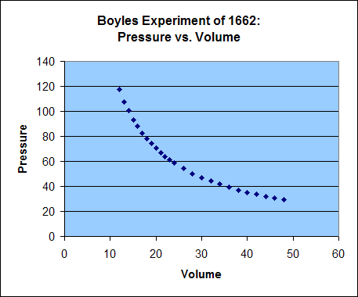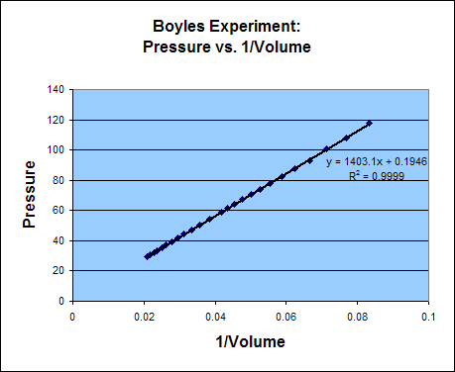

Exercise 2 Boyle’s Law I
Sulfur dioxide (SO₂), a gas that plays a central role in the formation of acid rain, is found in the exhaust of automobiles and power plants. Consider a 1.53- L sample of gaseous SO₂ at a pressure of 5.6 x 10³ Pa. If the pressure is changed to 1.5 x 10⁴ Pa at a constant temperature, what will be the new volume of the gas ?

0.57 L

YOU MUST USE TEMPERATURE IN KELVIN OR YOU WILL BE SORRY (AND WRONG).

2. Charles’ Law – Experiments have shown that when pressure and the number of moles is kept constant:
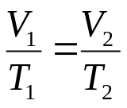

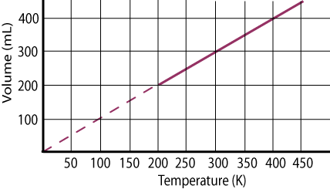

Exercise 4 Charles’s Law
A sample of gas at 15ºC and 1 atm has a volume of 2.58 L. What volume will this gas occupy at 38ºC and 1 atm ?

3. Gay-Lussac’s Law- Experiments have shown when volume and the number of moles are kept constant:
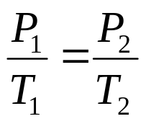

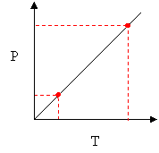
Exercise 4 Gay-Lussac’s Law
A sample of gas at 15ºC and 2.46 atm is heated to 336 ºC. What will the new pressure be?

4. Combined Gas Law- Only the number of moles is held constant.
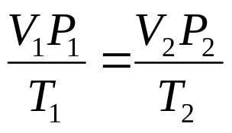

Memorize this one and you know all the rest. Get it?

5. Avogadro’s Law- The volume of a gas, at a given temperature and pressure, is directly proportional to the quantity of gas. The picture says it all:

These balloons each hold 1.0 L of a different gas at 25C and 1 atm.

Each balloon contains the same number of moles of their respective gas and the same number of particles.

In other words—it doesn’t matter what type of gas you’ve got when P, V and T are equal the number of moles are equal.

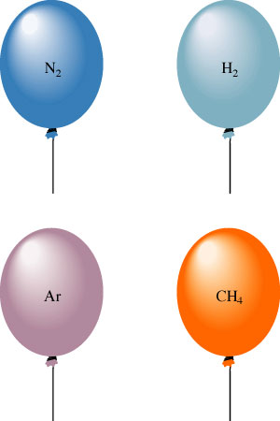

V₁ = V₂
n₁ n₂
Relationship between n and V
Increased number of gas particles =
Increased number of collisions with the walls of the container=
Increased total force of collisions =
Inside pressure greater than outside pressure=
Container expands

Exercise 5 Avogadro’s Law
Suppose we have a 12.2-L sample containing 0.50 mol oxygen gas (O₂) at a pressure of 1 atm and a temperature of 25ºC. If all this O₂ were converted to ozone (O₃) at the same temperature and pressure, what would be the volume of the ozone ?

8.1 L

6. Ideal Gas Law- Like the tee shirt says Perv= nert.
PV = nRT
You must use these units for each variable:
P= Pressure in atm V= Volume in Liters n= Moles R= 0.08206 L-atm/mol-k T = Temp in Kelvin

Exercise 6 Ideal Gas Law I
A sample of hydrogen gas (H₂) has a volume of 8.56 L at a temperature of 0ºC and a pressure of 1.5 atm. Calculate the moles of H₂ molecules present in this gas sample.

0.57 mol
